# **Telework** Ergonomics Self-Assessment

**Approved by the Workplace Strategy Council and OFM Collaborative April 2021.**

The goal of this ergonomic evaluation is to educate you in what an ergonomic workstation should look and feel like, for you to be able to identify early warning signs that can allow small problems to develop into serious ones. The better we understand your specific needs the better this evaluation will be for you in the long run.

This assessment is vital for us to assist you in the proper setup of your workstation. The individual sections of this form play a key role in this. It is important for you to fill out the entire form to ensure all of the necessary information is provided as part of the telework/ergonomics process and/or in case of a formal assessment being done.

If this assessment is being completed based on medical need, please contact your HR office to discuss appropriate process moving forward.

## Employee Information

|  |  |
| --- | --- |
| Employee Name: | Job Title: |
| Supervisor Name: | Date: |
| Division: | Telework/Office Location: |

## Work Information

|  |  |  |
| --- | --- | --- |
| Is this a shared workspace?  Yes No | | Breaks taken away from work area?  Yes No |
| Percentage of time spent in each type of work function | | |
| ___ % Using keyboard  ___ % Using computer mouse  ___ % Ten key | ___ % Writing/notetaking  ___ % Telephone (w/out headset)  ___ % Other | |
| Other significant tasks: | | |
| Reason for assessment:  New Employee Telework Agreement Prevention Follow up Discomfort Medical Issue Other  (Note: if reason is due to medical issue please contact your HR office) | | |
| Please provide any additional information you would like to be considered. | | |

## State Owned Equipment

Please check all state owned equipment you currently have in your possession at your telework location:

Equipment Inventory (What is currently used in the telework environment?)

|  |  |  |  |
| --- | --- | --- | --- |
| **Include model or specs if pertinent, i.e. basic or ergonomic design keyboard** | **state issued** | **personal** | **Describe other items used, i.e. lumbar pillow, floor mat, etc.** |
| Desk |  |  |  |
| Desk type: sit/stand or standard? |  |  |  |
| Chair (adjustable?) |  |  |  |
| Laptop/Tablet |  |  |  |
| Docking station |  |  |  |
| Keyboard |  |  |  |
| Keyboard tray |  |  |  |
| Mouse |  |  |  |
| Monitor(s) |  |  |  |
| Headset |  |  |  |
| Printer |  |  |  |
| Phone (Cell/Desktop) |  |  |  |
| Footrest |  |  |  |

## Equipment Assessment

Reminder: If this assessment is being completed based on medical need, please contact your HR office to discuss appropriate process moving forward.

### Chair

|  |  |  |  |
| --- | --- | --- | --- |
| **Item** | **Yes** | **No** | **Suggested Actions if “no”** |
| My chair is comfortable and working appropriately.  I get uncomfortable when I sit for long periods. |  |  | * DIY: Create a standing station and alternate your positions throughout the day. Ensure that your keyboard, mouse and monitor screen are at the correct height (see illustration below). |
| When I lean against the backrest, my feet are fully supported by the floor. |  |  | * Add a footrest. * DIY - books or boxes, duct taped as needed. |
| My chair provides support for my lower back. |  |  | * Add a lumbar cushion. * DIY: Use a rolled towel behind your low back. Pin on a strap to make it stay in place better. * Some chairs are more comfortable with a vertical pillow added. |
| When using the backrest, I can sit without the chair edge pressing into my thighs or the backside of my knees. |  |  | * Adjust chair height to back of bent knees. * Use a footrest to raise your feet slightly. * Add a cushion to the backrest to make the seat pan smaller. |
| My armrests support my forearms while keeping my upper arms and shoulders relaxed. The armrests don’t get in the way of pulling close to my desk to avoid reaching. |  |  | * Raise the armrests and/or adjust them closer to you if you find yourself leaning to one side to use them. * Add padding to the armrests if they’re too low or too hard. * Lower the armrests if they make you shrug your shoulders. * Lower or remove the armrests if they bump into the front edge of your desk when you pull up to your keyboard. |

a dotted line running through two hands showing the neutral wrist posture 

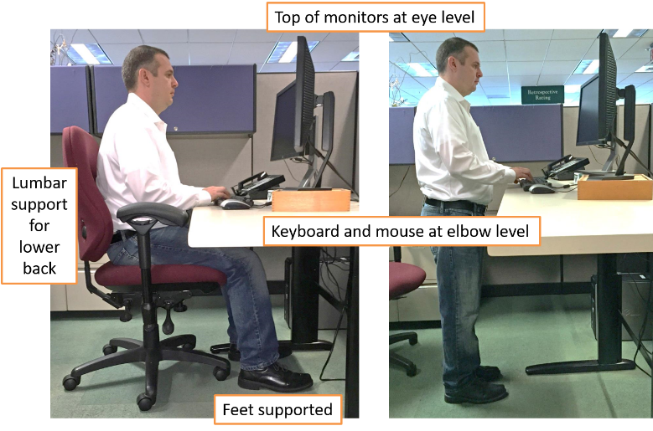

### Keyboard, Monitor and Mouse

|  |  |  |  |
| --- | --- | --- | --- |
| My elbows stay close to my sides and my wrists are mostly neutral (not bent) when I use my keyboard and mouse.  Many keyboards have foldable feet under them. Sometimes it helps to flatten the feet or other times, to leave the keyboard at an angle. Pay attention to what helps make your wrists straighter. |  |  | * Raise or lower workstation * Raise or lower keyboard * Raise or lower chair * Change the keyboard tilt * Check posture * Alter the keyboard feet and check your wrist posture |
| My mouse is the same level and next to my keyboard. |  |  | * Move mouse closer to the keyboard |
| I adjusted the screen brightness, contrast and font size so my eyes are comfortable when looking at the screen. |  |  | * Adjust Settings - * Click on Windows key/ Settings/System/Display * Blink often on purpose * Look across the room often, or out the window, to change your focal point. |
| My mousing hand and arm feels good without aches or pains. |  |  | * Try switching to the other hand for a while to give your uncomfortable hand a rest. You can change mouse button settings in the computer control panel. * Investigate other types of pointing devices. |
| My monitor is located directly in front of me. My neck is in neutral and not rotated. |  |  | * Reposition monitor – align the center of the monitor with the middle of your body. |
| I have two monitors, and I’m able to view them both without turning my head too much side-to-side. |  |  | * If you use both monitors equally, have them as close together as possible with the split between them centered in front of you. * If your monitors are wide, try to keep most of your work towards the inside half of each monitor, not out towards the edges where you would have to turn your head to see your work. * If you use one screen more than the other, place it centered in front of you. Place the monitor you use less often off to one side and angled towards you. Move windows you’re using for any length of time to the centered monitor. |
| I can lean against my backrest and see the screen clearly without leaning forward.  The correct distance from the userdepends on  the size of the monitor, the font, screen resolution  and the individual user (e.g. vision and use of bifocals  or progressive spectacles) |  |  | * Reposition monitor—lean against the backrest and reach out in front of you to measure the distance. Start with the monitor about an arm’s length away. Adjust the distance as needed for eye comfort. |
| I don’t wear glasses and the top of my monitor is near eye level.  Or—  I wear progressive lenses or bifocals and the screen is low enough for me to view it without tilting my chin up.  a model sitting on chair with correct eye view to the monitor |  |  | * If you have a separate keyboard and mouse~~,~~ in addition to your laptop, raise or lower the monitor so the top of the screen is at eye level. * If you tend to tilt your chin up to read the screen, lower the monitor a few more inches. * Raise the chair and add a footrest if needed. * Tilt the screen so that it’s at a more natural reading angle. |
| I take mini-pauses to relieve static posture and to rest my eyes. I alternate between sitting and standing, or move around before I get tired or have discomfort. |  |  | * Set reminders to take breaks * Refocus your eye gaze on something 20 feet away every 20 minutes * Blink often on purpose |

### Work Station/Surface

|  |  |  |  |
| --- | --- | --- | --- |
| **Item** | **Yes** | **No** | **Suggested Actions if “no”** |
| I have sufficient legroom under my desk. Nothing under the desk encroaches into my leg space, or compromises my posture or could cause a tripping hazard. |  |  | * Rearrange workstation – * Make more space under the desk so that you can’t possibly catch your foot on a cord or other obstacle. |
| Items that I use frequently are located close to me. Items that I use less often are in the “occasional work” area. an arial view of working space map including non-working, occasional work, and usual work areas |  |  | * Rearrange workstation |

### Accessories

|  |  |  |  |
| --- | --- | --- | --- |
| **Item** | **Yes** | **No** | **Suggested Actions if “no”** |
| If I use the phone while writing or keying, I use a headset or speakerphone. |  |  | * Use speakerphone * Obtain a headset * Use ear buds |
| I can look at reference documents while typing without bending my neck very much. |  |  | * Use a copy holder * DIY: Prop up papers on a 3-ringed binder turned sideways. Put a binder clip on the narrow edge to keep papers from sliding off. |

### Laptop

|  |  |  |  |
| --- | --- | --- | --- |
| **Item** | **Yes** | **No** | **Suggested Actions if “yes”** |
| I use a laptop computer for long periods of time. |  |  | * Get appropriate laptop accessories if possible, such as a separate keyboard and mouse. * If using the laptop screen as monitor, raise it up to eye level. * If using the laptop screen as monitor, ensure screen is large enough to see clearly. |

### Safety

|  |  |  |  |
| --- | --- | --- | --- |
| **Item** | **Yes** | **No** | **Suggested Actions if “no”** |
| I have reviewed the Telework Safety checklist (page 8) and I have made the necessary corrections to my workstation,  OR  I have reviewed the Telework Safety checklist (page 8) and do not have any trip hazards around my work area, such as wieldy cables, mats, piles of things on the floor, etc. |  |  | * Prevent safety hazards with good housekeeping. * Keep work area free from clutter that can contribute to slips, trips and falls. |

Following completion of this self-assessment, please discuss any concerns or requirements with your supervisor or HR consultant. All completed assessments should be submitted to your supervisor or HR consultant depending on your agency’s practice.

## Employee/ Person Completing Assessment

|  |  |
| --- | --- |
| Name: |  |
| Signature: | Date: |
| Additional Comments: | |

## Supervisor or HR Consultant

|  |  |
| --- | --- |
| Name: | Position: |
| Signature: | Date: |
| Comments: | |

## Telework Safety Self-Assessment Checklist

|  |  |  |
| --- | --- | --- |
| **General** | **Yes** | **No** |
| 1. Workspace is away from noise, distractions, and is devoted to your work needs? |  |  |
| 2. Workspace accommodates workstation, equipment, and related material? |  |  |
| 3. Floors are clear and free from hazards? |  |  |
| 4. Phone lines and electrical cords are secured under a desk or along wall, and away from heat sources? |  |  |
| 5. Temperature, ventilation, and lighting are adequate? |  |  |
| 6. All stairs with four or more steps are equipped with handrails? |  |  |
| 7. Carpets are well secured to the floor and free of frayed or worn seams? |  |  |
| **Fire Safety** | **Yes** | **No** |
| 8. There is a working smoke detector in the workspace area? |  |  |
| 9. A home multi-use fire extinguisher, which you know how to use, is readily available? |  |  |
| 10. Walkways aisles, and doorways are unobstructed? |  |  |
| 11. Workspace is kept free of trash, clutter, and flammable liquids? |  |  |
| 12. All radiators and portable heaters are located away from flammable items? |  |  |
| 13. You have an evacuation plan so you know what to do in the event of a fire? |  |  |
| **Electrical Safety** | **Yes** | **No** |
| 14. Sufficient electrical outlets are accessible? |  |  |
| 15. Computer equipment is connected to a surge protector? |  |  |
| 16. Electrical system is adequate for office equipment? |  |  |
| 17. All electrical plugs, cords, outlets, and panels are in good condition?  No exposed/damaged wiring? |  |  |
| 18. Equipment is placed close to electrical outlets? |  |  |
| 19. Extension cords and power strips are not daisy chained and no permanent extension cord is in use? |  |  |
| 20. Equipment is turned off when not in use? |  |  |
| **Other Safety/Security Measures** | **Yes** | **No** |
| 30. Files and data are secure? |  |  |
| 31. Materials and equipment are in a secure place that can be protected from damage and misuse? |  |  |
| 32. You have an inventory of all equipment in the office including serial numbers? |  |  |